1. Write a html page to display the following using the tags as shown in the parenthesis:

Use Section tag to divide into sections. 5 points

**Front End Task #1** (Bold ,H1)

Todays Date : __ ____ __ _ ___ (H4)

Todays Day : __ ____ __ _ ___ (H4)

**About Me** (Bold,H2)

Name : _ _ _ _ __ (H3)

Favourite Subject : _________________(H3)

Favourite Teacher : _ _ __ ___ (h3)

Deliverable :

**Code:**

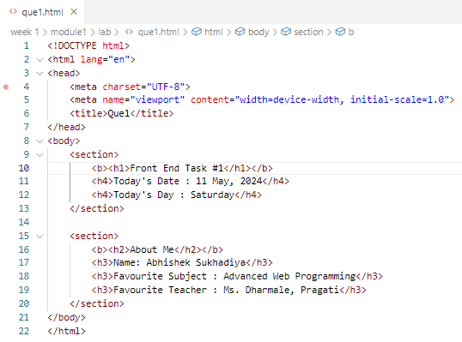

**Web Page:**

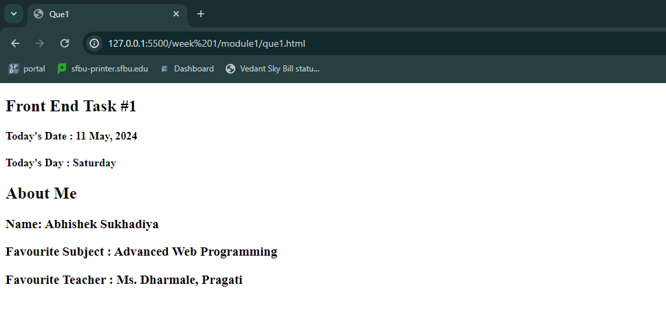

1. Now use this knowledge to display the page as follows: 5 points

**Code:**

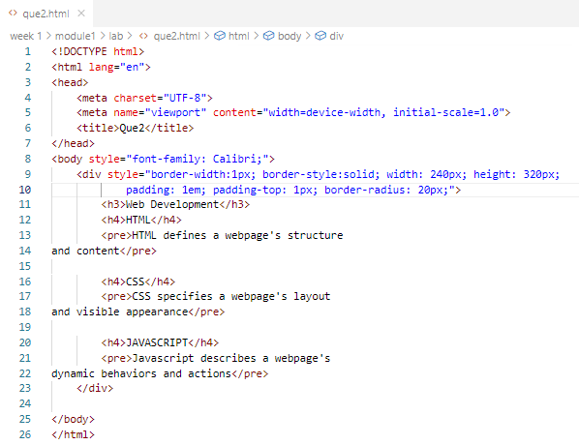

**Web Page:**

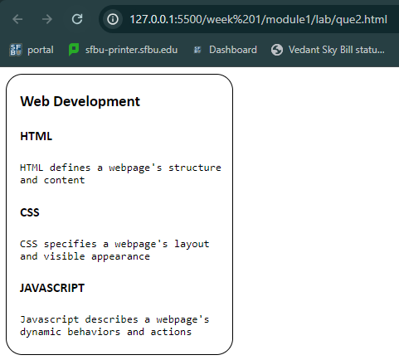

1. Write the code to display the web page as shown in the screen shot below: 20 pts

Pay attention to the details and generate the clone of the web page exactly as you see.

Deliverables:

1. Paste the screen shot of code and web page generated

**Code:**

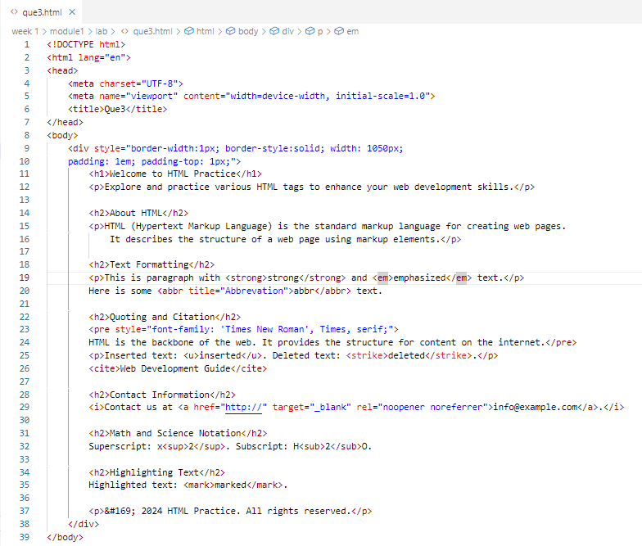

**Web Page**: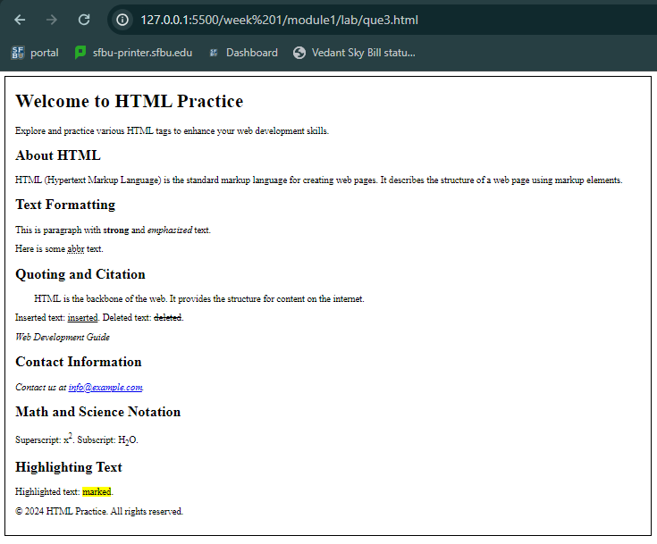

1. Mention the specific tags used and their description .

Used tags:

* <html>: html basic tag
* <head>: html header tag
* <meta>: html metadata specific tag
* <title>: html webpage title tag
* <body>: html body page tag
* <div>: Division tag
* <h1>: Header-1 tag | Use to define largest sized Heading tag
* <p>: Paragraph tag | Use to define paragraph tag, Used for describe paragraphs.
* <h2>: Header-2 tag | Use to define the second largest Heading tag
* <strong>: Strong tag | Use to define text with strong importance
* <em>: Emphasize tag | Use to define emphasize the text
* <abbr>: Abbreviation tag | Use to define abbreviation in the text
* <pre>: Preformatted tag | Use to print text preformatted, i.e. as it is
* <u>: Underline tag | Use to define underlined text
* <strike>: Strike tag | Use to define deleted text
* <cite>: Citation tag | Use to define citation in the text
* <i>: Italic tag | Use to italic the text
* <a>: Anchor tag | Use to define a clickable-link
* <sup>: Super tag | Use to define Superscript in the text
* <sub>: Sub tag | Use to define Subscript in the text
* <mark>: Mark tag | Use to highlight text

Final Deliverable:

1. This Document with the required deliverables.
2. Create a folder ,Lab1 . Copy all the html files of questions in it. Zip the folder and submit the folder.

NOTE : There will be two submissions. 1. A doc file , 2. A folder containing code files

**Rubric :**

| **Criteria** | **Excellent (5)** | **Good (3-4)** | **Satisfactory (1-2)** | **Poor (0)** |
| --- | --- | --- | --- | --- |
| Task 1 HTML Structure | The HTML structure is well-formed and follows the given requirements accurately. | Minor issues with the HTML structure. The overall structure is good but with some room for improvement. | Significant issues with the HTML structure. The content is present but not structured properly. | HTML structure is incorrect or missing entirely. |
| Task 2 Modified HTML | The modified HTML accurately reflects the changes requested, and the content is well-presented. | Minor issues with the modified HTML. Some details may be missing or not accurately reflected. | Significant issues with the modified HTML. Major details are missing or misrepresented. | The modified HTML is incorrect or not provided. |
| Task 3 Accuracy & Details | The web page accurately replicates the provided screenshot, paying attention to details such as colors, fonts, and spacing. | The web page closely resembles the screenshot but may have minor inconsistencies in details. | The web page has significant deviations from the screenshot, with noticeable inaccuracies. | The web page does not resemble the provided screenshot. |
| Overall Presentation & Clarity | The web page is well-presented, easy to read, and visually appealing. | The web page is generally clear and readable, but some improvements could be made in presentation. | The web page lacks clarity and may be challenging to read. | The web page is poorly presented and difficult to understand. |
| Total Points | 20-25 | 13-19 | 5-12 | 0-4 |